TASK ON CLOUDFRONT & ROUTE 53
- Configure VPC peering in cross regions.
Configured cross-region VPC peering to enable secure communication between VPCs.
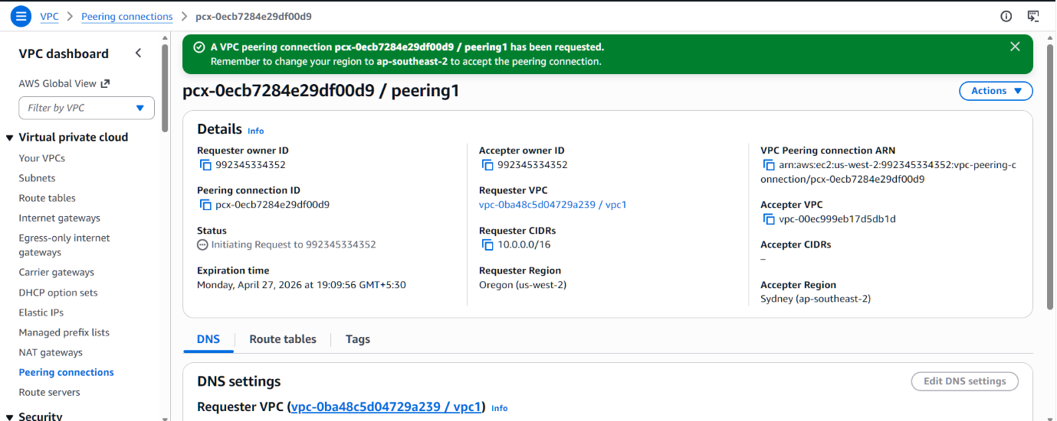
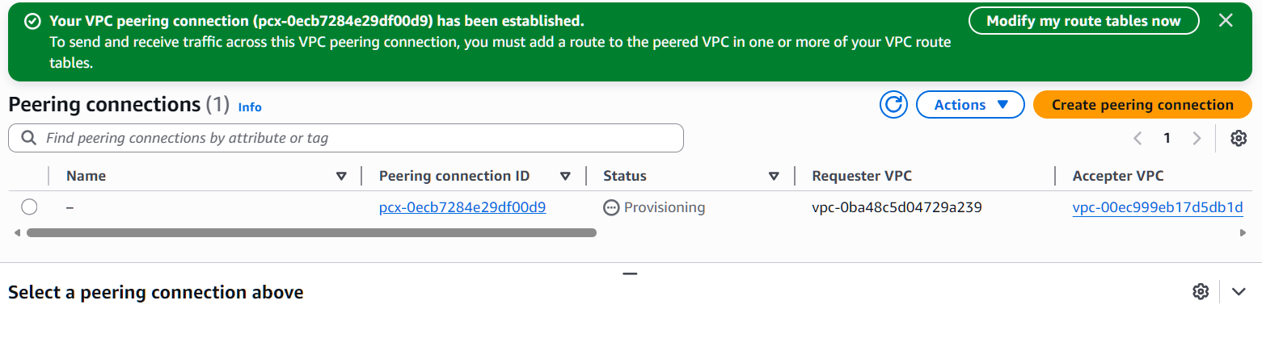
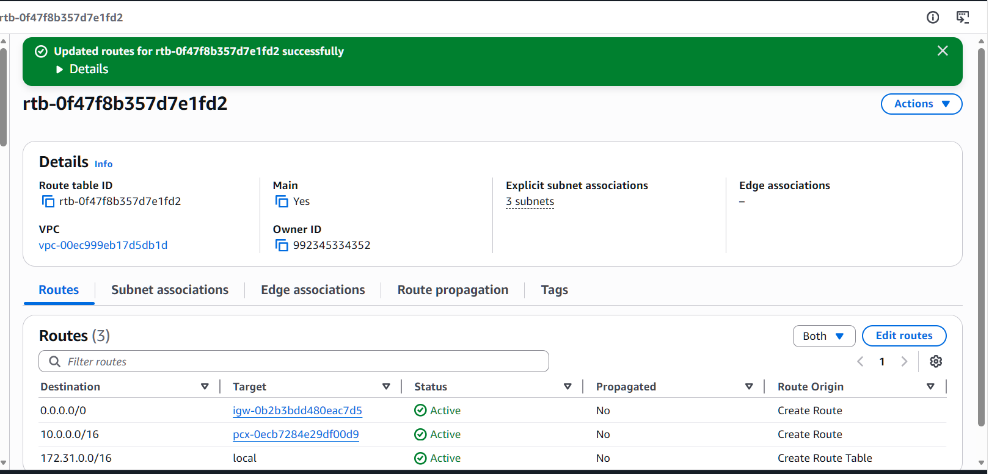

- Purchase one domain from GoDaddy.
Purchased a domain from GoDaddy for website hosting.
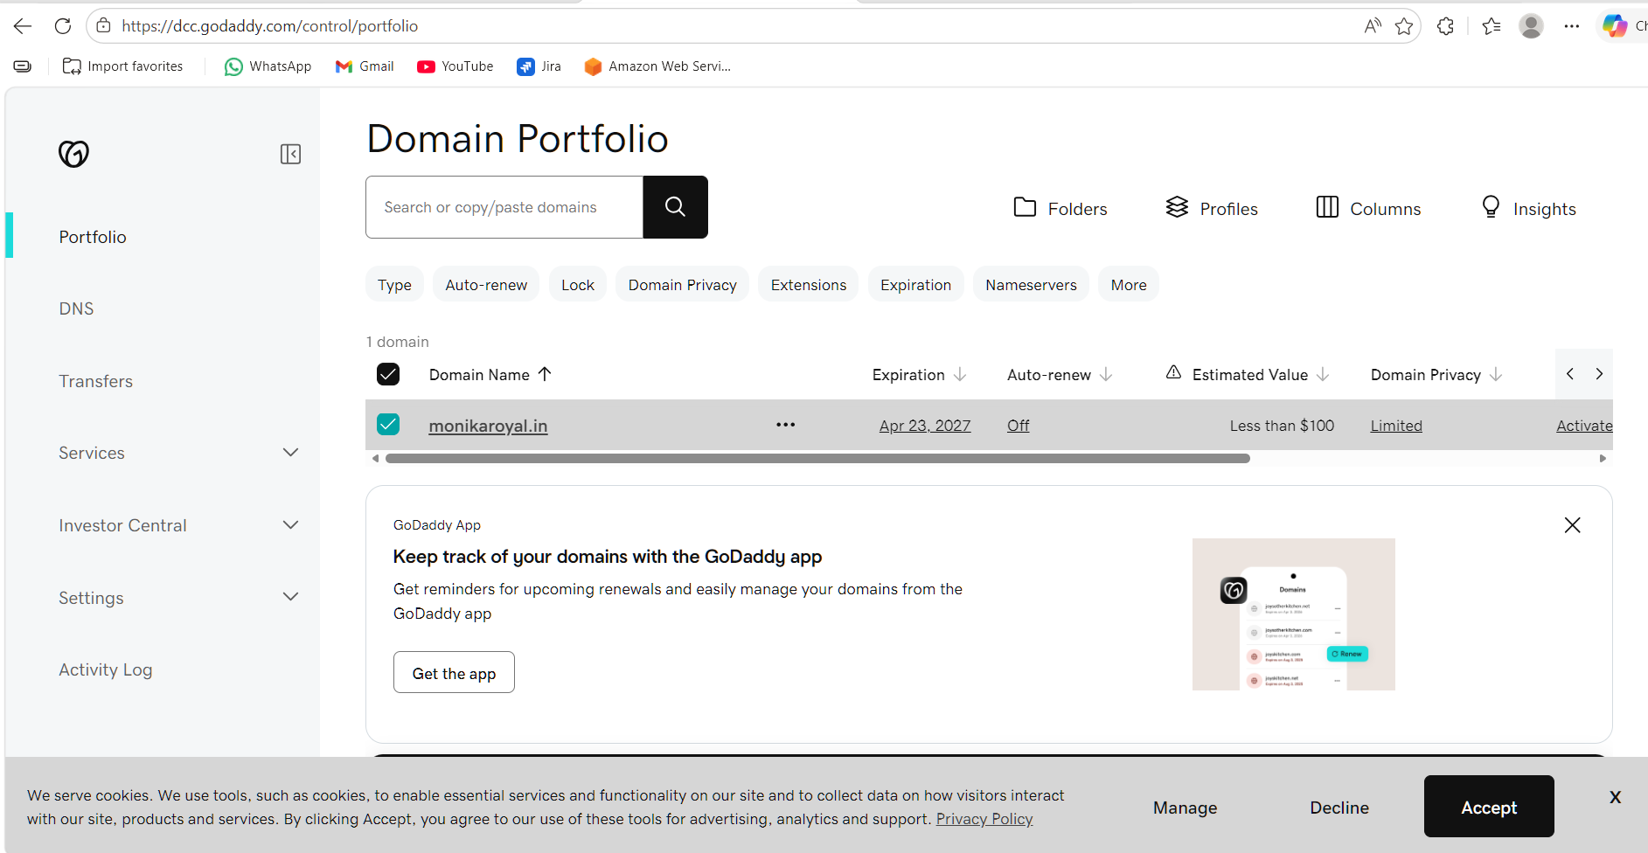
- Deploy static website in S3.
Deployed a static website using an Amazon S3 bucket with hosting enabled.
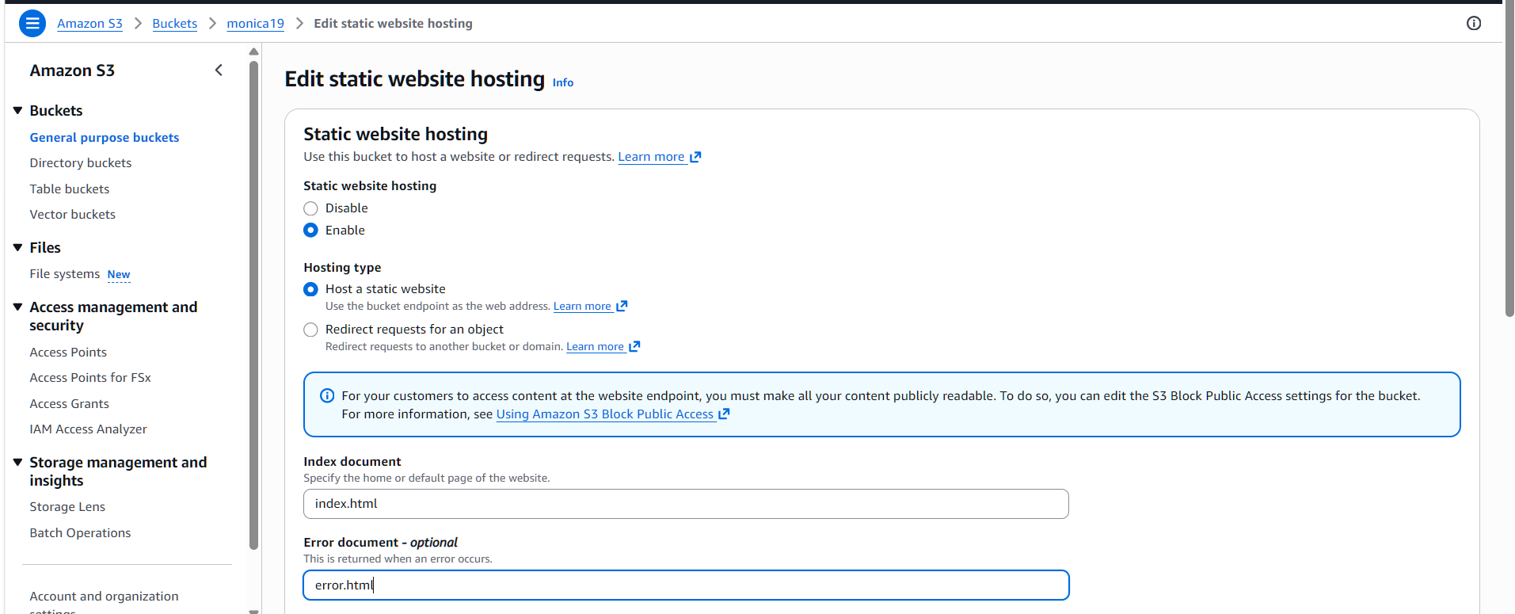
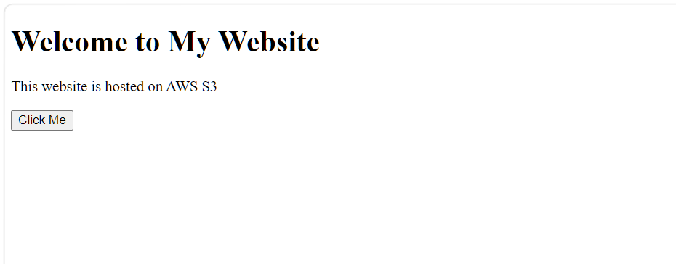

- Create a CDN and attach one SSL certificate.
Created a CloudFront CDN and attached an SSL certificate for secure content delivery.
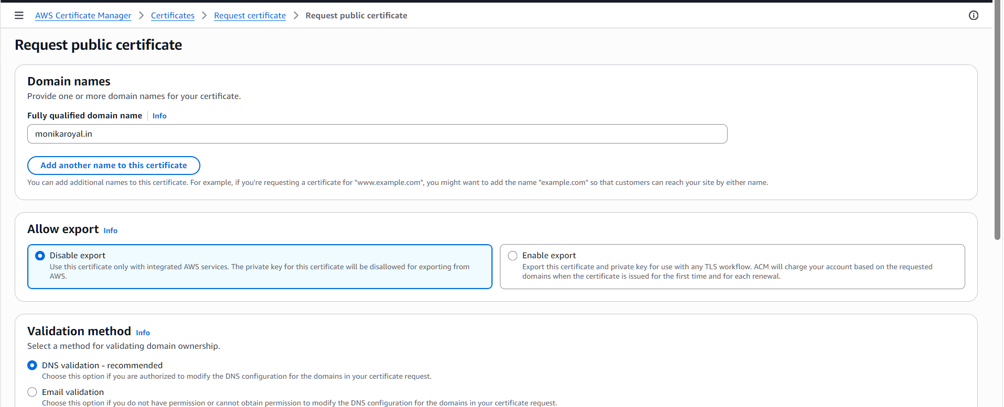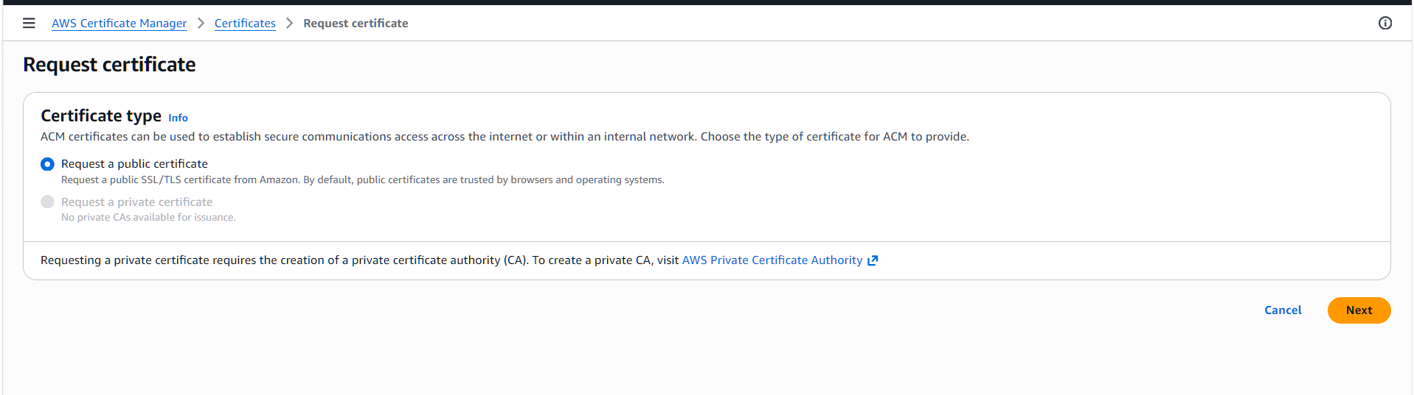
Created a new bucket name with the domain name
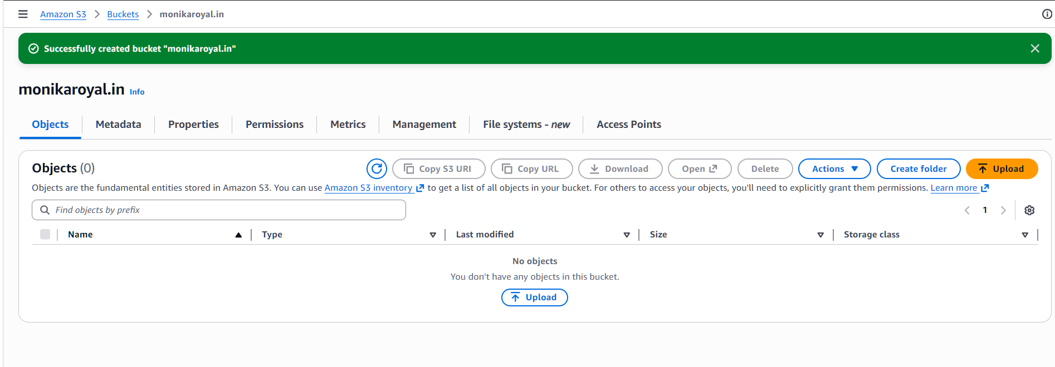
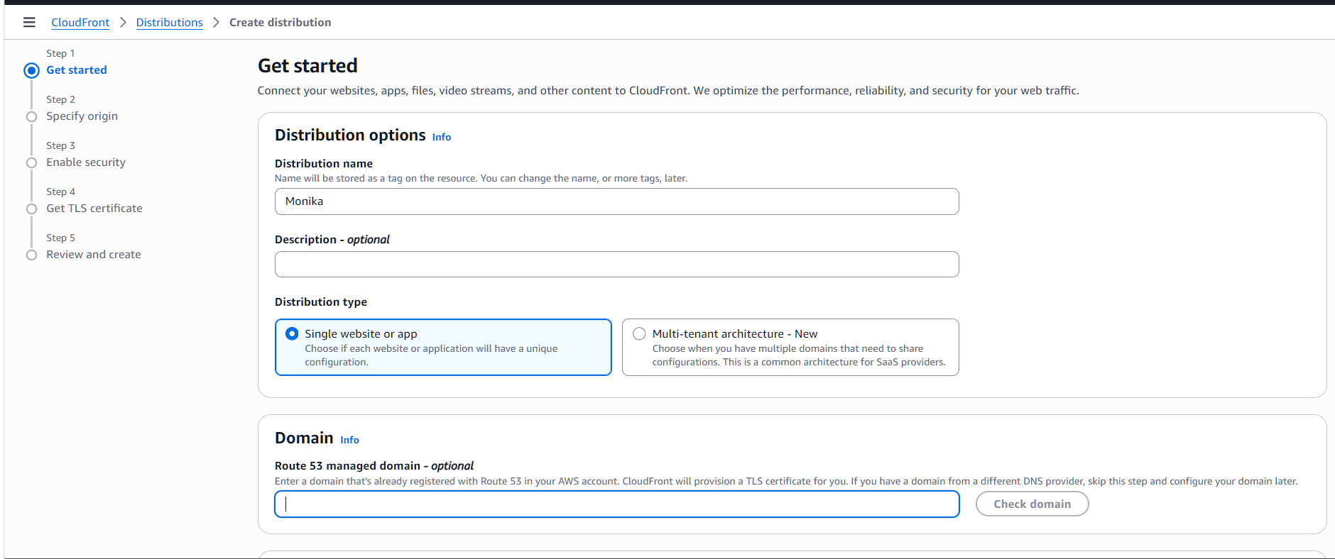
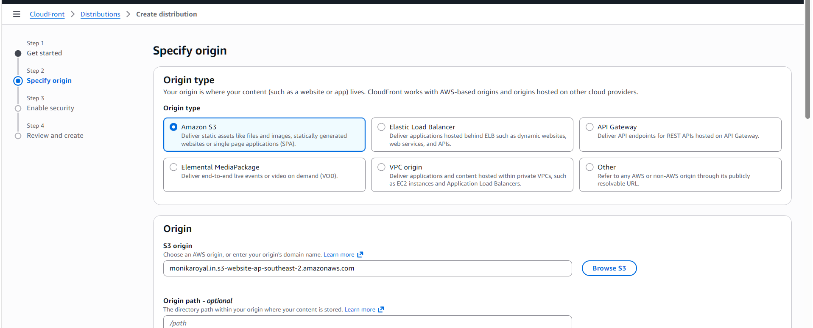
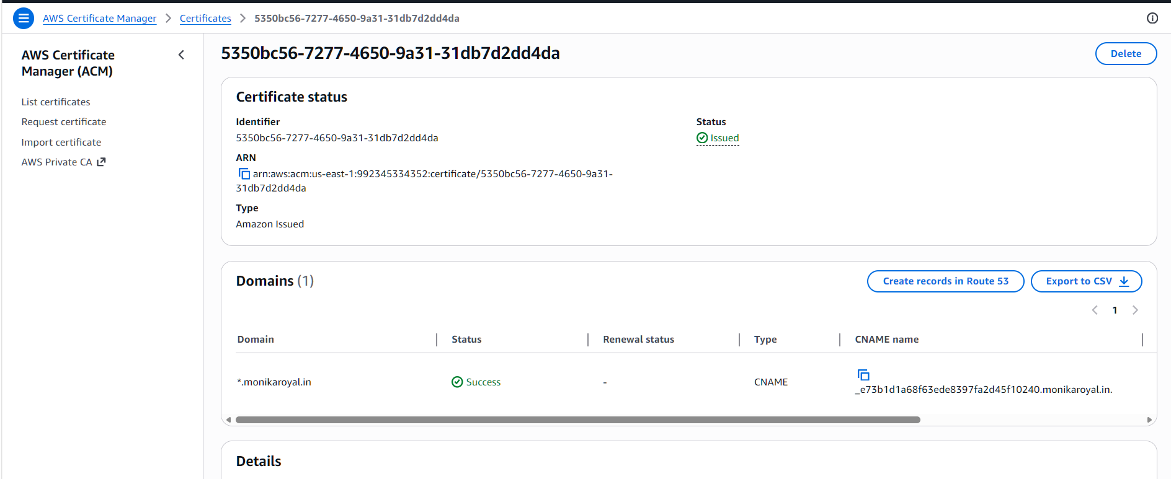

5.Create a Route 53 hosted zone and map the domain with the CDN.
Configured a hosted zone in Route 53 and mapped the domain to the CDN.
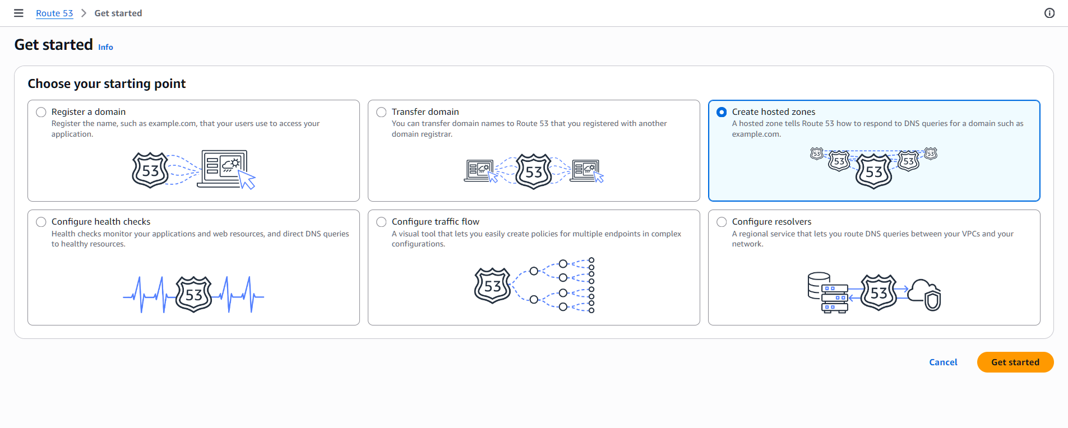
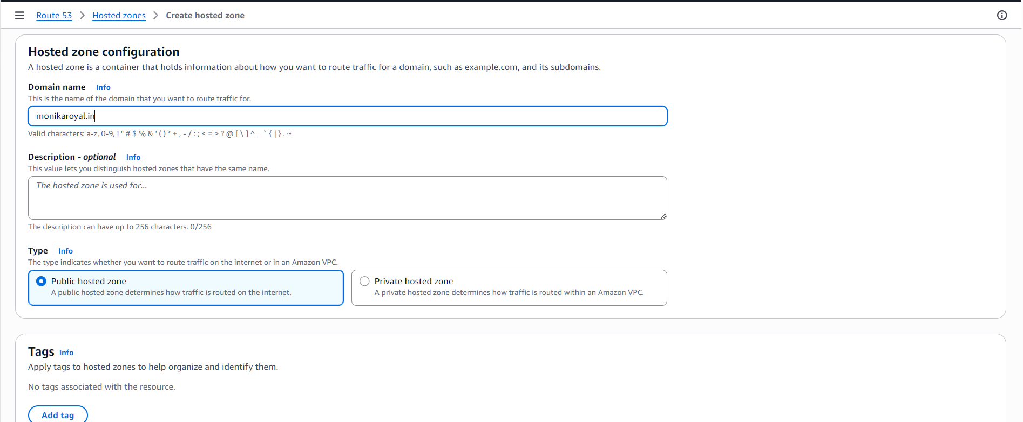
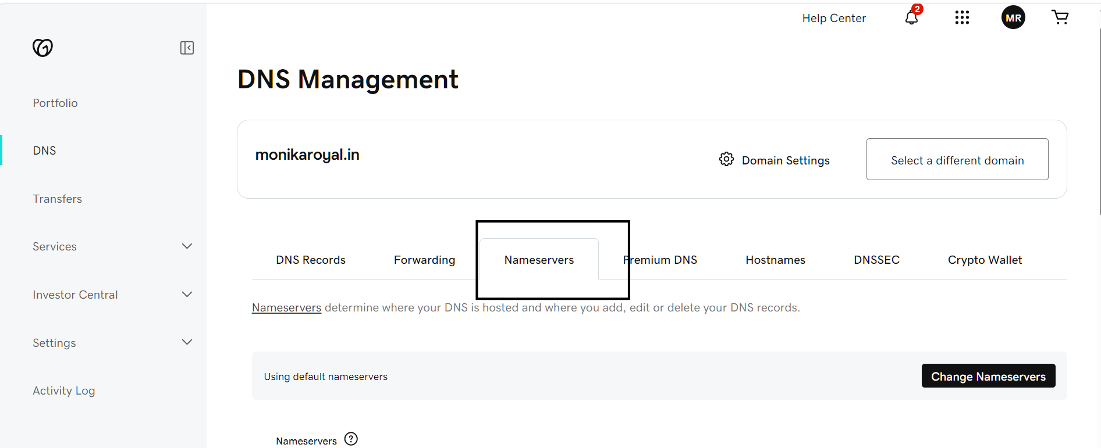
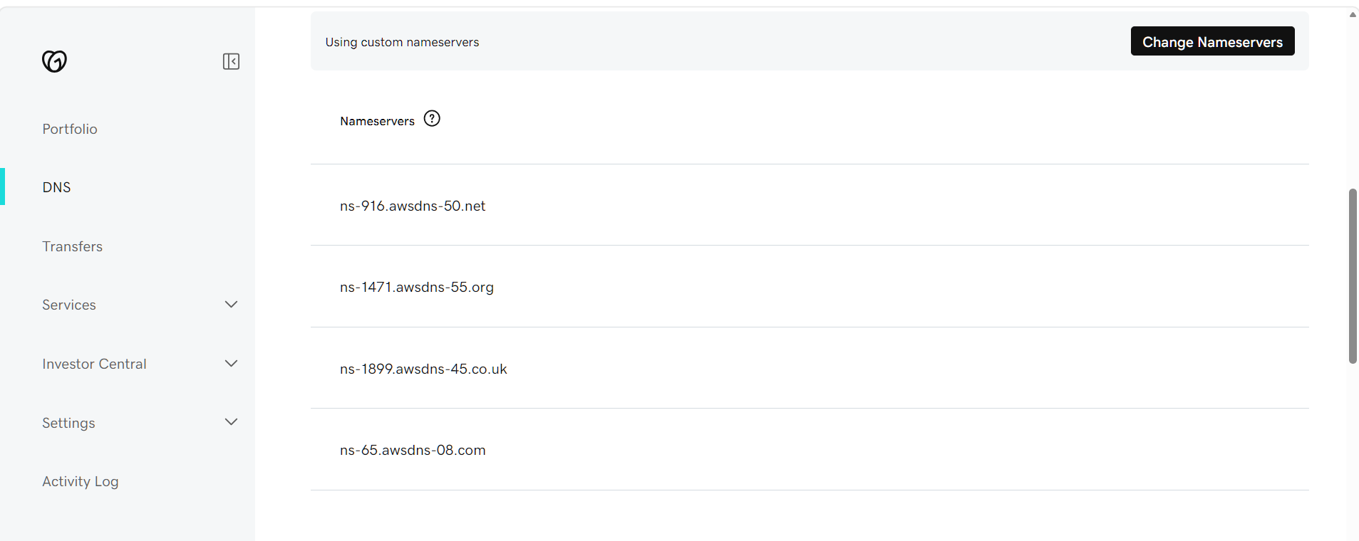
6Update the index.html in the S3 bucket and ensure the updated file is accessible using the domain name.
Updated the index.html file in S3 and verified the changes via the domain.
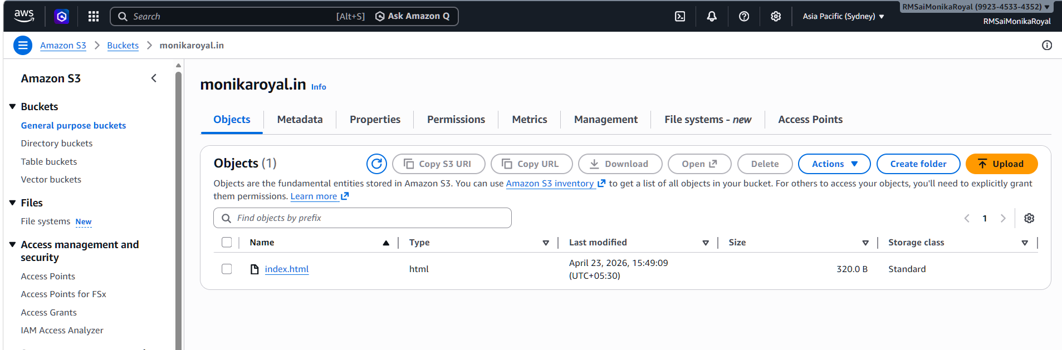
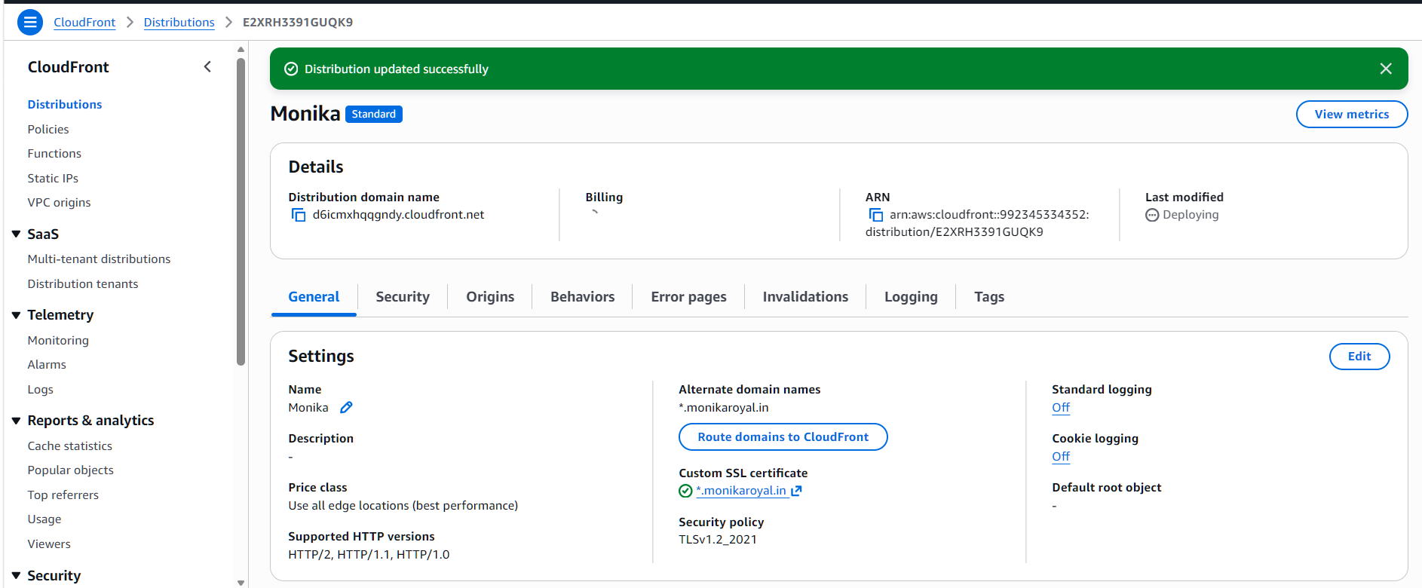
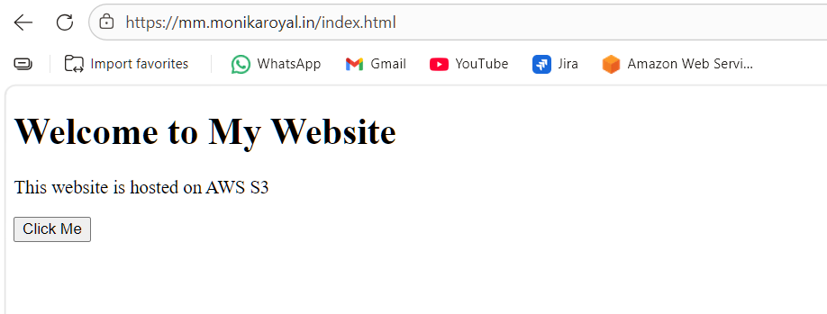7. Share the domain name in Slack to test the connectivity.
Shared the domain link on Slack to test connectivity.
My First S3 Website

